NATIONAL RESEARCH UNIVERSITY

HIGHER SCHOOL OF ECONOMICS (HSE)



Title of the Report:

FLIPKART SALES DASHBOARD

Business Intelligence Assignment 2
Data Period: January 2018 - December 2018

Student:
Mohd Sufiyan Ansari
Narasimha Naidu
1. Business Requirements and Data Preparation

1.1 Business Problem
Flipkart is one of leading India’s e-commerce platform which gains popularity recently, which needs a comprehensive sales performance monitoring system to track revenue, profitability, and customer behaviour across different states, product categories, and payment methods during the financial year 2018. The management team lacks a consolidated view of key performance metrics, making it difficult to identify underperforming regions, top customers, and loss-making product categories in a timely manner.

1.2 Business Goals
- Monitor overall sales revenue and profitability trends on a monthly and quarterly basis
- Identify top-performing and underperforming states to optimise regional marketing strategies
- Analyse customer purchasing patterns to improve customer retention and target high-value customers
- Evaluate product category and sub-category performance to guide inventory and pricing decisions
- Understand payment method preferences to streamline payment infrastructure

1.3 Key Questions the Dashboard Answers
- What is the total revenue, profit, and profit margin for FY 2018?
- Which months show the highest and lowest profitability?
- Which states generate the most and least revenue?
- Who are the top customers by revenue and how much do they contribute?
- Which product categories and sub-categories are most profitable?
- What payment methods do customers prefer and what percentage of revenue comes from each?
- How does performance vary across quarters?

1.4 Target Audience
This dashboard is designed for Flipkart's senior management team, specifically:
- Sales Directors — to monitor quarterly and monthly revenue targets
- Regional Managers — to compare state-level performance and allocate resources
- Category Managers — to evaluate product line profitability
- Finance Team — to track profit margins and identify loss-making segments

1.5 Data Description
The dataset consists of two related tables covering 1,500 orders from 336 unique customers across India in 2018:

Table | Columns | Records | Description
Details | Order ID, Amount, Profit, Quantity, Category, Sub-Category, Payment Mode | 1,500 | Transaction-level sales data
Orders | Order ID, Order Date, Customer Name, State, City | 500 | Order and customer information

1.6 Data Preparation and Cleaning
- Imported both CSV files (Details.csv and Orders.csv) into Power BI Desktop
- Established a one-to-many relationship between Orders and Details files
- Confirmed Order Date column was correctly formatted as Date type
- Validated that Amount and Profit columns contained numeric values only
- Confirmed all 500 orders in Orders table matched records in Details table

1.7 Summary Statistics

Metric | Value
Total Revenue | Rs. 4,37,771
Total Profit | Rs. 36,963
Profit Margin | 8.4%
Total Orders | 1,500
Total Units Sold | 5,615
Avg Revenue per Customer | Rs. 1,303
Top State by Revenue | Maharashtra (Rs. 1,02,498)
Top Category by Revenue | Electronics (Rs. 1,66,267)
Most Used Payment Method | COD (46%)
Best Performing Month | January (Rs. 61,632)

2. Dashboard Screenshot
The dashboard below provides a single-screen view of Flipkart's sales performance for FY 2018. It includes 5 KPI cards, 5 interactive charts, and 2 filters (Quarter and State).

Figure 1: Flipkart Sales Dashboard — FY 2018 (Power BI Desktop)
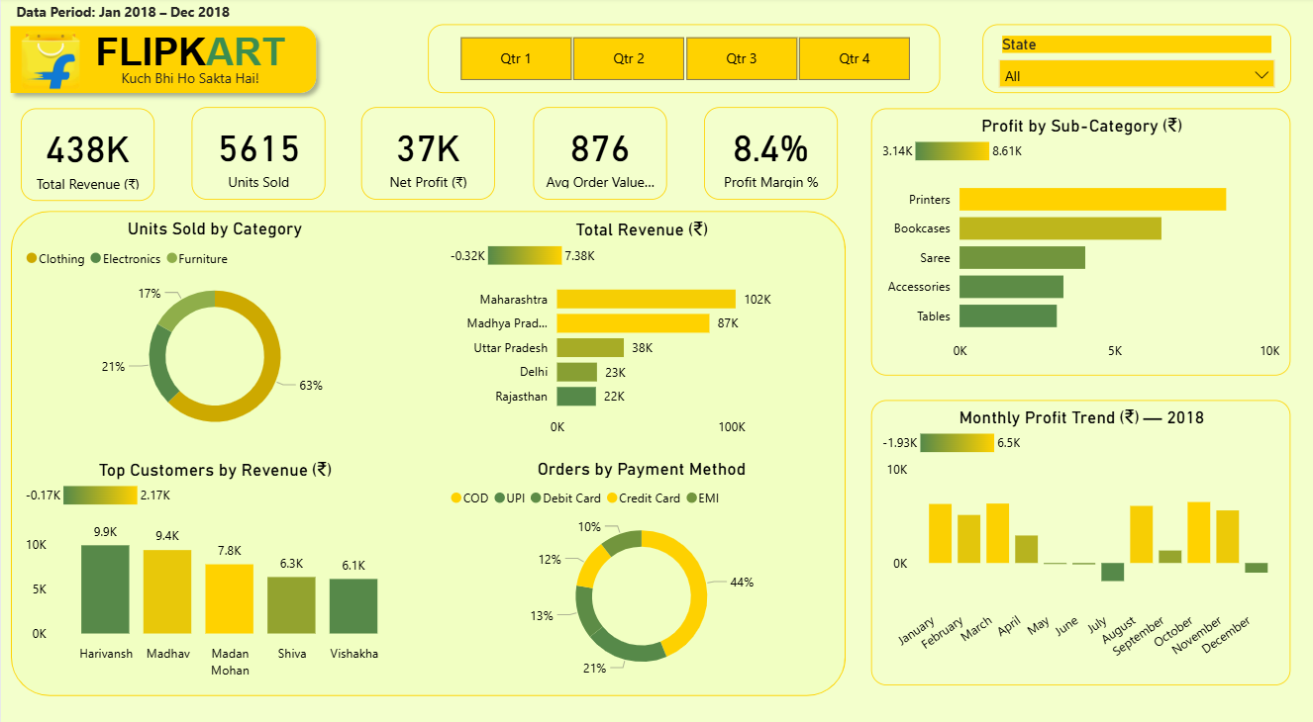

3. Publicly Accessible Link
The dashboard has been uploaded on Yandex disk and is accessible via the following link:

https://disk.360.yandex.com/d/vpKY8Te0-eXKjw

4. Dashboard and Performance Alerts

4.1 Dashboard Components
The dashboard consists of the following components arranged in a single-screen layout:

Component | Type | Description
Total Revenue (Rs.) | KPI Card | Shows total sales amount of Rs. 4,37,771 for FY 2018
Net Profit (Rs.) | KPI Card | Displays total profit of Rs. 36,963 earned in FY 2018
Units Sold | KPI Card | Shows total quantity of 5,615 units sold across all categories
Avg Order Value (Rs.) | KPI Card | Shows average revenue per customer of Rs. 1,303
Profit Margin % | KPI Card | Displays overall profit margin of 8.4%
Total Revenue (Rs.) by State | Horizontal Bar Chart | Ranks top 5 states by revenue; Maharashtra leads with Rs. 1.02L
Top Customers by Revenue (Rs.) | Vertical Bar Chart | Shows top 5 customers; Harivansh highlighted as top customer in gold
Monthly Profit Trend (Rs.) 2018 | Column Chart | Shows monthly profit trend; red bars indicate loss months (May, Jul, Sep, Dec)
Units Sold by Category | Donut Chart | Shows category split: Clothing 63%, Electronics 21%, Furniture 17%
Orders by Payment Method | Donut Chart | Shows payment preferences: COD 46%, UPI 22%, Debit Card 13%
Profit by Sub-Category (Rs.) | Horizontal Bar Chart | Ranks sub-categories by profit; Printers highlighted as top performer

4.2 Filters and Interactivity
Filter | Type | Function
Quarter Filter | Button Slicer (Qtr 1-4) | Filters all charts to show data for selected quarter only
State Filter | Dropdown Slicer | Filters all charts to show data for selected state only
Cross-filtering | Built-in Power BI | Clicking any chart element filters all other charts automatically

4.3 Alarm Triggers
The following metrics serve as alarm triggers for management action. These are not implemented technically but are described as decision rules:

Alarm | Trigger Condition | Recommended Action
Low Profit Margin | Profit Margin % drops below 5% | Review pricing strategy and identify loss-making SKUs immediately
Monthly Loss | Monthly Profit goes negative (below Rs. 0) | Investigate that month's orders for high discounts or returns
COD Dominance | COD payment exceeds 50% of orders | Flag cash flow risk; push digital payment incentives
Customer Concentration | Top 1 customer contributes more than 10% of revenue | Diversify customer base; reduce dependency on single customer
State Underperformance | Any top-5 state shows revenue decline of more than 20% | Deploy regional sales team for recovery campaign
Sub-Category Loss | Any sub-category shows negative profit for 2+ months | Review pricing, discontinue or renegotiate supplier terms
Inventory Alert | Any category shows units sold below 500 per quarter | Review demand forecasting and adjust procurement

5. Peer Dashboard Review
Reviewer: Mohd Sufiyan Ansari and Narasimha Naidu
Dashboard Being Reviewed: Monthly Sales Performance Dashboard
Dashboard Created By: Noor Mohammad and team

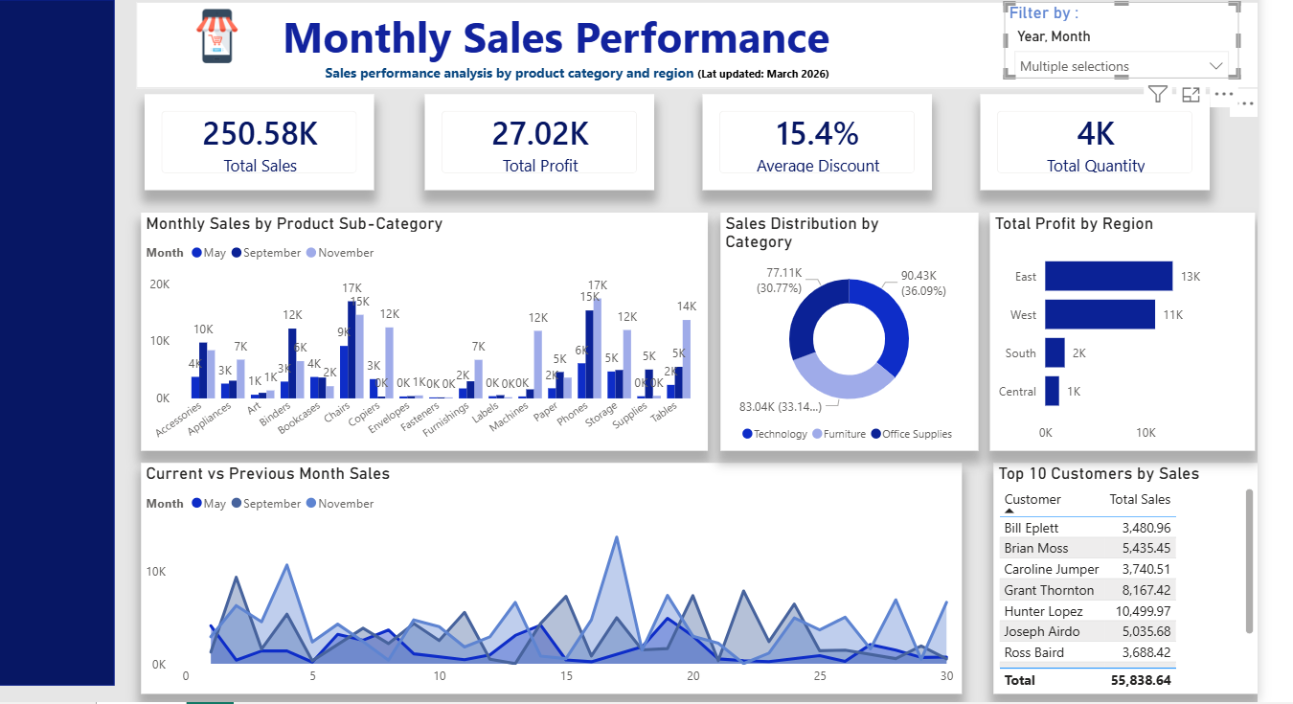

Part 1: Summary and First Impressions
Dashboard Description
This dashboard is designed to monitor Monthly Sales Performance, specifically focusing on sales revenue, profitability, discount rates, and product quantity sold across different product categories, sub-categories, and geographic regions. The dashboard tracks performance over time and provides a comparative view of sales trends across multiple months.
Initial Impression
At first glance the dashboard has a professional appearance with a clear title, company logo, and a well-structured layout. The use of a consistent blue colour scheme gives it a corporate and polished look. The four KPI cards at the top immediately communicate the most important summary metrics, which is good practice. However, upon closer inspection, the dashboard feels somewhat information-dense, particularly the Monthly Sales by Product Sub-Category chart, which contains too many categories to read comfortably in a single view. Overall, the purpose of the dashboard is clear but navigating and extracting specific insights requires some effort from the user.

Part 2: Analysis of Strengths
Strength 1 — Clear and Informative KPI Cards
The four KPI cards at the top of the dashboard (Total Sales: 250.58K, Total Profit: 27.02K, Average Discount: 15.4%, Total Quantity: 4K) are well-chosen and immediately give the manager a high-level snapshot of business health.
Strength 2 — Effective Use of Multiple Chart Types
The dashboard makes good use of varied visualisation types that are well-suited to their respective data. The donut chart for Sales Distribution by Category clearly shows the three-way split between Technology (36%), Office Supplies (33%), and Furniture (31%), making proportional comparisons intuitive. The horizontal bar chart for Total Profit by Region efficiently ranks the four regions (East, West, South, Central) without clutter.
Strength 3 — Useful Temporal Filter and Date Context
The dashboard includes a Year/Month filter with multiple selection capability in the top right corner, along with a visible last-updated date (March 2026) in the subtitle. This temporal context is critical for a management dashboard, as it tells the viewer exactly how fresh the data is and allows them to drill into specific time periods.

Part 3: Constructive Critique and Recommendations
A. Clarity and Usability
Issue 1 — Sub-Category Chart is Overcrowded
The Monthly Sales by Product Sub-Category bar chart attempts to display all sub-categories simultaneously, resulting in very narrow bars that are difficult to read and compare. With 17 sub-categories shown at once, the X-axis labels overlap and the chart becomes visually overwhelming. This undermines the usability of what should be one of the most informative charts on the dashboard.
Recommendation: Limit this chart to the Top 5 to 8 sub-categories by revenue, or add a filter that lets the user select a specific category (Technology, Furniture, Office Supplies) to drill down into its sub-categories.
Issue 2 — Top 10 Customers Table Lacks Visual Hierarchy
The Top 10 Customers by Sales table displays customer names and total sales as plain text without any visual encoding. While the data is accurate, it is difficult to quickly identify the top performer or spot the gap between customers. The table also appears to be cut off, showing only 7 customers despite being titled Top 10.
Recommendation: Replace the plain table with a horizontal bar chart showing customer names on the Y-axis and sales on the X-axis, sorted descending. Highlight the top customer with a distinct accent colour – that what I have done in my dashboard where I display top customer. This makes the ranking immediately visual and eliminates the need to read and compare numbers manually.
Issue 3 — No Profit Margin Metric
While Total Sales (250.58K) and Total Profit (27.02K) are both shown as KPI cards, the Profit Margin percentage is not explicitly displayed. A manager cannot immediately assess whether 27K profit on 250K revenue represents good or poor performance without calculating this themselves.
Recommendation: Add a Profit Margin % KPI card next to the existing four cards.
Issue 4 — Regional Analysis is Limited
The Total Profit by Region chart shows only four regions with minimal detail. It does not show revenue by region, units sold, or which categories drive each region's performance. A manager looking at this chart cannot determine why South and Central regions are significantly underperforming or what actions to take.
Recommendation: Add a region-based filter or drill-through feature so clicking on a region updates all other charts to show only that region's data.
Issue 5 — No Targets or Benchmarks Shown
The dashboard presents actual performance numbers but provides no comparison against targets, budgets, or industry benchmarks. A manager looking at Total Sales of 250.58K cannot determine whether this is above or below the sales target for the period. Without this context, the dashboard describes what happened but does not help the manager assess whether it is good or bad.
Recommendation: Add a target line to the Current vs Previous Month Sales chart showing the monthly sales target. For KPI cards, consider adding a small indicator arrow (up/down) showing whether the metric is above or below target, similar to a traffic light system. Even a simple label such as Target: 300K below the Total Sales card would add significant context.
Issue 6 — Monochromatic Colour Scheme Limits Insight
The entire dashboard uses various shades of blue for almost every chart element. While this creates visual consistency, it makes it difficult to distinguish between different data series or highlight important information. For example, in the Sub-Category chart, all months use similar shades of blue, making the three series hard to differentiate at a glance.
Recommendation: Introduce a small accent colour palette of 2-3 colours that carry semantic meaning.

Overall Summary and Score
Criteria | Score (1-5) | Brief Comment
Clarity of Title and Purpose | 4/5 | Clear title and subtitle; purpose is immediately evident
Relevance of KPIs | 3/5 | Good KPIs but missing Profit Margin % which is critical
Quality of Visualisations | 2/5 | Good variety but sub-category chart is overcrowded
Layout and Composition | 4/5 | Clean layout with logical top-to-bottom flow
Use of Filters | 3/5 | Year/Month filter works but more drill-down options needed
Colour Palette and Design | 3/5 | Consistent but too monochromatic
Actionability of Insights | 3/5 | Good starting point but lacks targets and benchmarks
Overall Impression | 3/5 | Professional and pleasant but not yet fully decision-ready
OVERALL SCORE | 26/40 (65%) | Good foundation with clear improvement opportunities

